
Prateek Rastogi
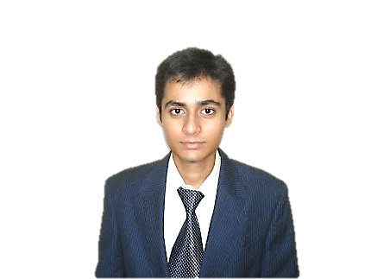
57, Siang Hostel, IIT Guwahati Email :- p.rastogi@iitg.ernet.in
Assam, India, Pin:-781039 Phone :- (+91)9085666650

Education
Currently Pursuing B.Tech In Computer Science And Engineering From IIT Guwahati (2010-2014).
Areas of Interest
Algorithms, Data Structures, Software Engineering, Web Based Application Development.
Skills
Programming Languages:-
- C, C++, C#, JavaScript, PHP, XHTML, CSS, VHDL, Shell Scripting.
Content Management Systems:-
- Wordpress, Joomla.
Software And Other Technological Skills:-
- Adobe Photoshop, Adobe Flash Professional, Adobe Dreamweaver, Adobe Illustrator, Adobe Acrobat X, Microsoft .NET 4.0 Framework.
- Microsoft Office Suit, MATLAB, MySql, Microsoft Visual Studio, Dev C++, CodeBlocks, Latex, UML.
Operating Systems:-
- Fedora, Ubuntu, Linux Mint, Mac OS Lion, Windows 7.
Projects
Simulation Website:-
- Developed A Web Application For Providing Simulation Analysis of Digital Electronic Circuits.
- Implemented Time Slot, File Upload and User Authentication Mechanism Using JavaScript, PHP and MySql.
Guide :-Dr. Santosh Biswas Duration :-Third Semester


Coursework
Theory:-
- Object Oriented Programming And Data Structure.
- Discrete Mathematics.
- Digital Design.
- Formal Languages And Automation Theory.
- Algorithms.
- Computer Organization And Architecture.
- Software Engineering.
- Introduction To Computation.
Laboratory:-
- Basic Electronics Lab.
- Hardware Lab.
- Data Structure In C++.
- System Software And Software Engineering.
- C Programming Lab.
Achievements
- Secured 1824 Rank Among Around 4,72,000 Candidates In Joint Entrance Exam 2010 Conducted By IIT’s.
- Notched 99.5 Percentile In All India Engineering Entrance Exam 2010 Conducted By CBSE.
- Active Member Of The Marketing Team Of Alcheringa-Annual Cultural Fest Of IIT Guwahati.
- Worked For Systemizing Hostel Preparation And Participation In Various Events Of Manthan(Annual Inter Hostel Cultural Competition), Spardha(Annual Inter Hostel Sports Competition) And GC(General Championship) And Facilitated Hostel To Triumph These Competitions.
Activities
- Joined NSS (National Service Scheme) To Work For The Cause Of Welfare Of Underprivileged And Environment.
- Participated In Various Events Of Techniche-Annual Technical Fest Of IIT Guwahati.

